Queensland University of Technology

Sprint 2 Retrospective

*IFB299 – group 45*

TUTOR: Mr Prakash Bhandari  
DATE SUBMITTED: 3rd November, 2017

|  |  |  |
| --- | --- | --- |
| STUDENT NAME | STUDENT NUMBER | ROLE |
| *Aiden Bird* | n9900489 | Product Owner |
| *Andrew Grant* | N9495291 | Developer |
| *Gyeongmin Jee* | N9665072 | Developer |
| *Sandra Finow* | N9144757 | Scrum Master |

sprint 2 retrospective

ifb299 – group 45

# TEAM communication

For sprint two, our communication remained at a high standard. Holding two weekly online Slack meetings on top of our workshop class ensured all members were up to date with tasks, goals, and deadlines. It also ensured all members could inform others about any of their issues or queries and resultingly these issues and queries were quickly alleviated. The layout of our Slack channels also aided with how well our team communicated, by having separate weekly channels and debugging channels for example, which can be seen in Figure 1 of the Appendices on page 5 of this document. Additionally, as per our contract, all team members effectively informed others if they were unable to attend meetings either via Slack or in person during our workshop classes.

Another aspect of excellent communication within the team was the medium of using meeting minutes. If a member was unable to attend a meeting or became unsure of their individual tasks which were delegated to them during a meeting, through using meeting minutes as a medium of communication, team members could confirm their tasks as well as understand the overall accomplishments and outcomes from the team meeting. Again, this communication ensured all team members were on the same page and could easily review previous meetings and their goals.

Overall, our team had great transparency and constantly kept other team members in the loop regarding their personal commitments, issues, achievements, and ideas. To improve on our current communications though, a Myer-Briggs Type Indicator test should be undertaken. This is opposed to traditional ice breakers and getting to know each team member’s personality through small talk and general conversation. The Myer-Briggs Type Indicator allows all team members to quickly identify other team member’s personality type, habits, and perspectives, and aids in identifying each team member’s strength and weaknesses. As such, communication is improved through knowledge of each member’s cognitive learning and communication styles generally associated to best fit each Indicator Type.

# TEAM PARTICIPATION

Requirements from the tutor and client for the sprint and weekly workshop tasks were recorded in Slack during the weekly meetings. The delegation of tasks agreed to by all members in the team meetings was recorded in the Meeting Minutes document by the SCRUM master for all members to view (Git location: IFB299-group45/doc/MeetingMinutes/Meeting_Minutes_Sprint_2.docx).

The tasks to be completed were outlined by the SCRUM master at the beginning of each meeting. The components of these tasks, who would complete each task and the timeframe in which the task had to be completed, were then discussed by the group. An example of these discussions can be seen in Figure 2 in the appendices.

After a short demo to the tutor of the website’s functionality, feedback from the tutor informed the group that more time must be spent testing and correcting errors. This was to ensure that the same errors that occurred during the demo did not occur in the final release of the application. The group therefor focused more on resolving any current issues the application had. These fixes were noted by the tutor in the next demonstration of the application.

Feedback from the tutor on our release and sprint plan alerted the group to various issues with the user stories. These issues included some stories not having story points assigned and an insufficient amount of work hours based on story points and the predicted time to complete the tasks. This feedback was incorporated into the Sprint 2 plan as the number of tasks, the story points assigned to these tasks and the time estimated to complete these tasks is more realistic and align better with what would be expected from a team of four.

# PROJECT QUALITY CONTROL

At the start of each week during this sprint, members individually had to present what they would be completing per week as well as for the entire sprint. At the end of each week each member uploaded to their code to GitHub and presented what they accomplished so far and discussed what needs to be done if any problems were encountered. Upon completion of an artefact, members would let others go through a reviewing process. This ensured that the artefact that was relevant to the actual website, was functional, passed the team’s acceptance criteria, and followed the sprint plan outlines.

An improvement from the previous sprint was that more frequent refactoring processes were performed to improve the code and structure quality of the website. Design was reconsidered to provide better quality of the website. At the end of the sprint, unit and verification tests were conducted and improvements were made to all errors found.

# INFORMING TUTOR AND CLIENT

Over the course of sprint two, all due dates and artefacts have been successfully documented and viewable to the client through Slack and Github. All pieces of work were submitted to Slack and/or Github before their due dates to ensure no late-submissions were encountered, and to also provide other members with time to read over the work for any errors and reflect on the items presented. No team member exceeded any due dates and all members worked well together, with high standards or communicating to submit everything on time.

# issues raised

Some minor issues which hampered the progress of this project include (1) that each member had different commitments such as work, (2) time constraints due to other university subjects, and (3) each member has different skill levels in relation to coding. Due to having different commitments, planning weekly team meetings was a slight challenge. Also, when other university subjects had other assessment items due, team members focused on their other subjects instead of the SmartCity project. Learning some Django related items was still a hurdle to overcome in this sprint, though due to having some previous knowledge from sprint one, these hurdles were overcome slightly quicker. Despite these minor issues being present, the team put in lofty standards of effort to ensure all item deadlines were met.

In terms of major or serious issues, one member lost use of his laptop as it had to be sent off for repairs and consequently was unable to be as productive during the workshop meetings for a bit over a month.

# APPENDICES

**Figure 1.** Snapshot of group 45’s Slack channels and example of a communications segment from one Week 13 team meeting on Slack.

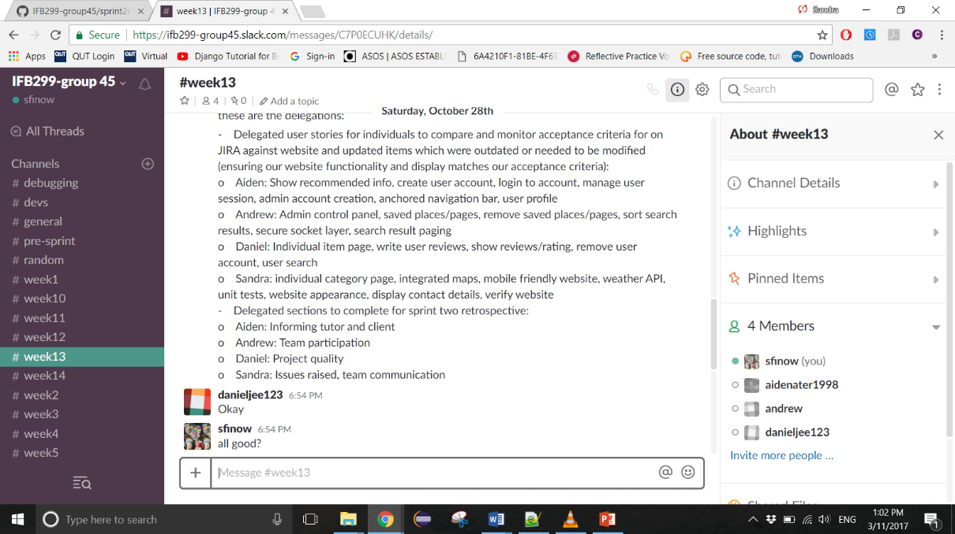

**Figure 2.** Example of a team discussion of tasks and task allocation on *Slack.*